# Incoherencies and Wrong Evaluations Observed in my Final Exam of EE-920

Program : eMasters – Communication Systems

Module : EE-920 – Wireless Communications

Roll No: 23156022

Name: Venkateswar Reddy Melachervu

1. For Q.22, I very clearly remember answering Option A. However, the evaluated response sheet I received from you shows as B. Indeed, I sent a message about this question in the wireless whatsapp group suspecting that options A and C both could be right answers.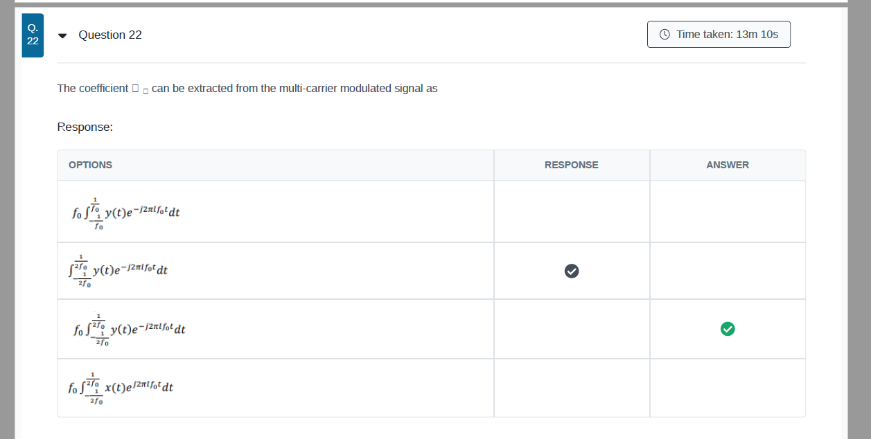
2. For Q.32, below is my response which shows the selected answer is option C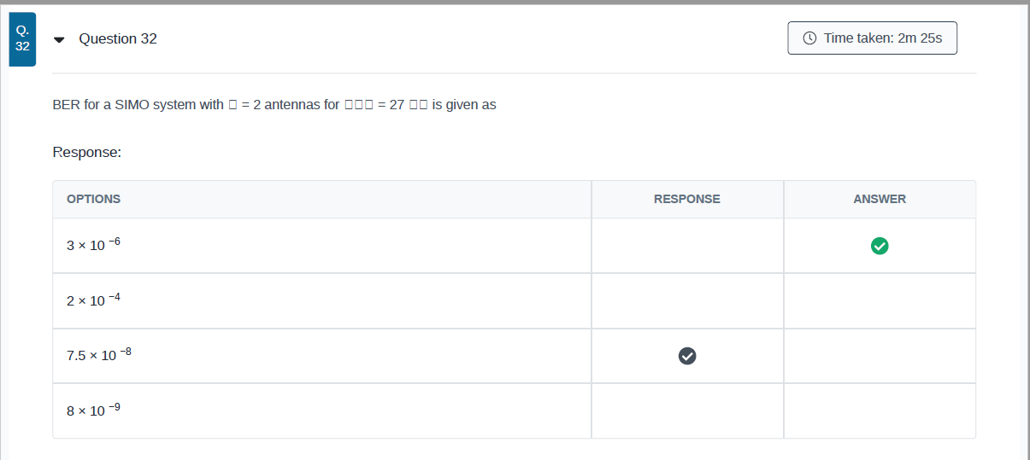
3. Ddd
4. ddd

Sincerely,

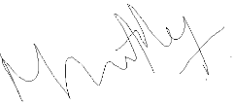

Venkateswar Reddy Melachervu